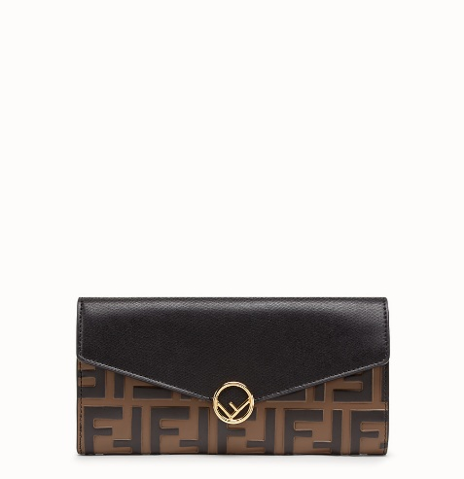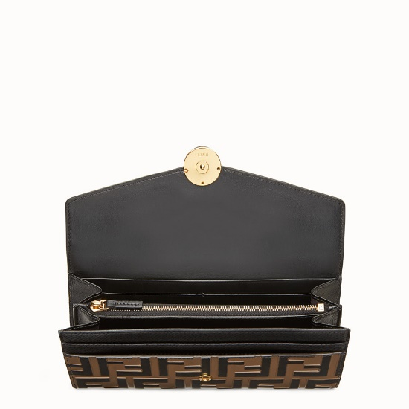

FENDI-CONTINENTAL

$770.00

COLOR :BLACK/RED/PINK  
SIZE : ONE SIZE  
IN STOCK

[Detail](http://127.0.0.1:49618/content/t111N4OiRbh2yVfRAAAB/hpgePlz/oehMasF/PMThN0I/21kHjic/6dqNUkf/kmCj2qj#collapse)

Continental F is Fendi wallet fastened with a press stud. Spacious and well-organized, with two gusseted pockets, a zippered pocket, ten card slots and flat side pockets. Made of black calf leather. FF pattern printed in relief and hand-painted in tones of black and brown. Gold-finish metalware. Made in Italy.

• Length:7.5 inches

• Height:3.5 inches

• Depth:0.4 inches

• Composition:100% Calf leather, inside: 100% Calf leather, 50% Cotton, 42% Polyamide, 8% Resins, embroidery: 100% Zamak

Universal Style #: Product Code:8M0251A6CBF13VK

[CARE & COMPOSITION](http://127.0.0.1:49618/content/t111N4OiRbh2yVfRAAAB/hpgePlz/oehMasF/PMThN0I/21kHjic/6dqNUkf/kmCj2qj#collapse1)

• Leather

• Imported